University Performance Model

Report

-Ankit Yadav(001271369)

-Ajay Goel(001897443)

**Contents**

**Topic Page**

University Model …………………………………………………………………………………………………..3

Basic Model………………………………………………………………………………………………..3

Attributes……………………………………………………………………………………………………4

Connections………………………………………………………………………………………………..4

University Object Model……………………………………………………………………………..5

Performance Analysis …………………………………………………………………………………………….6

Student Feedback……………………………………………………………………………………….6

Student Feedback Model…………………………………………………………………………….7

Alumnus Survey…………………………………………………………………………………………..8

Alumnus Feedback………………………………………………………………………………………8

Alumnus Survey and Feedback Model…………………………………………………………8

Sequence Diagrams

Bird Eye View University Model…………………………………………………….……….……9

Student Feedback Sequence Diagram…………………………………………..….…..……..9

Alumni Rating Sequence Diagram……………………………………………………………….10

**University Model**

In a University model, there can be various methods on which it carries out its functions.

In our model, University is the center for all. It is connected to:

* **Student Directory**: It consists of all the student data present in the university. Student attributes like student ID, student name, contact, address details will be stored.
* **Alumni Directory**: It consists of all the alumni data which has cleared all the desired courses they intended at time of enrollment. Attributes like alumni Id, Alumni Name, contact, address details will be stored.
* **College**: Each university has a college which is the sub head of all the departments. It can have various campuses.



**# College** is further connected to

* **Department:** College can have various departments. It will also have some attributes like Department Id and Department name. Department id the primary key which will be unique for all the departments.
* **College Student Directory:** Each college will have specific student directory which will be accessed by all the university at higher level. It will have the student id, student name, address and contact of the student.

# Now, **Department** is huge. It will have some roles and responsibilities which will be common for all the departments.

* **Department Course Catalog**: Each department will have a catalog of various courses

Courses can be core and electives.

Core courses will be mandatory for students to take in their lifecycle of university and electives will be chosen by the students themselves.

* **Department Student Directory**: As the student data and basic details are coming from college, there will be a mapping of
* **Roles**: Department will have certain roles like Faculty, Staff to carry out the functioning.
* **Degree**: Each department will offer degree to the student who has cleared all the courses of each department.

# **Department Course Catalog:** It consists of the various courses offered by the department. For electives, it depends on the student but for core it depends on the department which course to offer.

It is further connected to course having many to one relationship. Every time student logs in then by selecting only single course, description can be given.

* **Course Offering:** It is connected to teacher and seat. As every course will have teachers and location where it is taught. Timings depend on the teacher so that attribute will be connected to teacher when called.

**# Department Student Directory:** It is connected directly to the student as we are taking direct data from the student. If any data changes then in this directory latest data is reflected.

# **Student:** Student is very important object in the model as university is dependent directly on the student.

It is connected to

* **College Student Directory:** Explained above.
* **University Student Directory:** Explained above.
* **Department Student Directory:** Explained above.
* **Transcript:** It is the document on which grades of all the courses taken by the student is mentioned.
* **Alumni:** As soon as the Student clears all chosen subjects and has finished the course. He becomes an alumnus and is given Alumni id.

# **Degree:** It is connected to the course and department as each department will have different types of degree depending on the course student had opted for.

# **Teacher:** It is connected to the course offering and to faculty.

There can be a case where teacher is a faculty of 2 or more subjects. All the details of the professor, timings and syllabus of the course is decided by the teacher which plays a master role in this.

**#Seat**: Location of the course will help us to determine the connection between the infrastructure and course. There should be a mapping present as it will help in managing all the courses available.

**#Course Load**: Managing transcripts based on subjects offered and location is important as it will help in making clear dimension of the whole model.

Below is the complete object model for university.

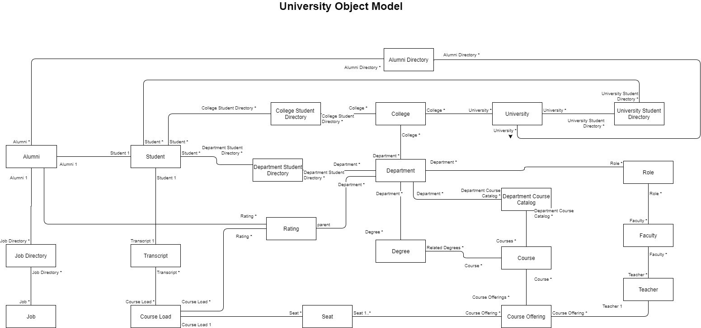

**Fig 1: University Object Model**

**Performance Method**

We have considered following 2 methods for reviewing the performance of university.

1. Student Feedback
2. Alumni Feedback via survey
3. Alumni professional growth
4. **Student Feedback**

We have given a facility of feedback in our university model. So, after completion of each course, student has to fill a mandatory feedback form about his experience of the particular course.

The flow of operations for the function can be explained as follows:

* Student will login to university portal with his credentials.
* After verification of the credentials from the student directory, student will be directed to his dashboard.
* From his dashboard, he can access the courses he has taken.
* Each of the completed course, will have a link for student feedback.
* After clicking on the link, student will be directed to a page, where he will enter the feedback.
* Feedback will not be on a single entity but multiple set of questions.
* We have created a calculateRating() method which will take the mean of all the ratings given by the student.
* This final rating will be the rating of Department from student perspective.
* Final rating will be calculated by combining the ratings of all the students who have taken the courses under a particular department.
* Now, after completion of this flow every Department will have total student rating and rating of every courses.
* On the basis of this data Department can take major decisions regarding courses and their pedagogy structure.



**2. Alumni Feedback via survey:**

In this, a mail will be sent to all the alumnus of the college yearly.

* The mail will consist of a link of survey.
* Alumnus can simply log in with the credentials and after verification from the alumni directory, it will redirect it to the survey page.
* The aim of the survey will be to get the alumnus point of view regarding the university structure.
* It will help the university to know the relevance of the courses with respect to the current job scenario.
* Survey will collect data of all the alumnus and will give the mean rating for every course.
* This survey will immensely help a department to modify course structure according to the current technological advancement in the industry.

**3. Alumni Feedback via professional growth:**

In this functionality, Alumni will not give feedback but he will just update the professional profile on the university alumni portal.

Also, We can create some method by which we will extract the LinkedIn profile of the alumnus.

* The aggregated data will give points to the various alumnus employment details like:

## Type and status of the company.

- Salary offered.

- Positions.

- Achievements.

* The rating class will have a function which will rank the department with respect to the relevance of its courses by using the above details.

This will be very important factor as it will provide the necessary data for the department to do any course structure for the benefit of the future students.

Now, the final rating will be as follows:

getFinalRating = (getRatingAlumnusSurvey, getRatingAlumnusJobDetail);

This rating will finally rank the department which will be helpful for the university to analyse the departments in a more rigorous manner.

This rating will also assist the student to analyze which courses to take according to their future career goals.

**Alumnus Survey feedback**



**Detailed Sequence Diagram**

1. Bird eye view of rating model

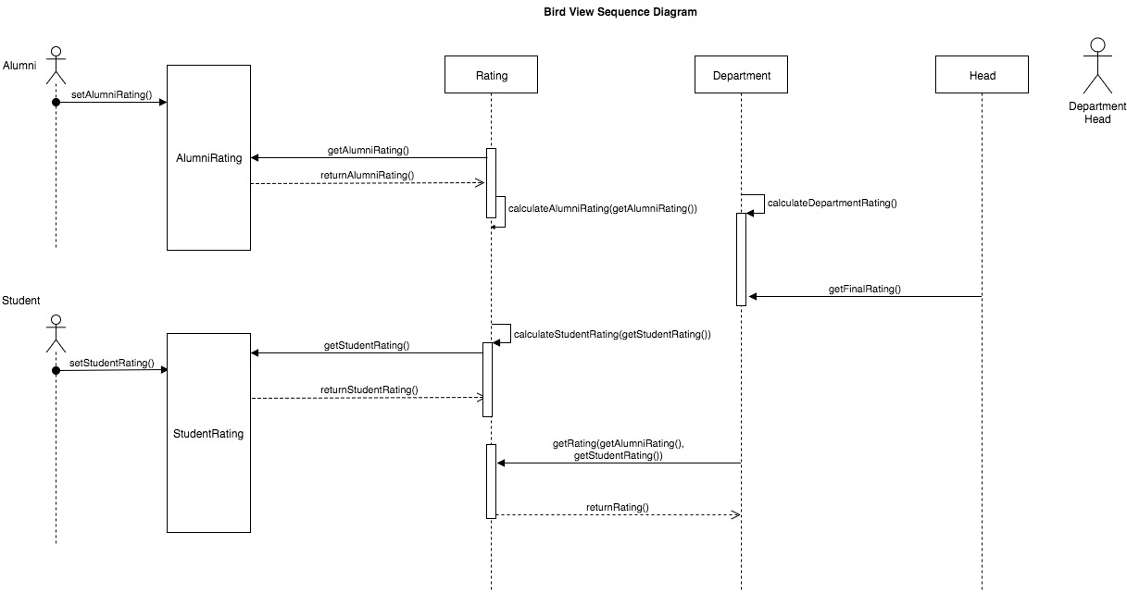

1. Student Rating sequence diagram

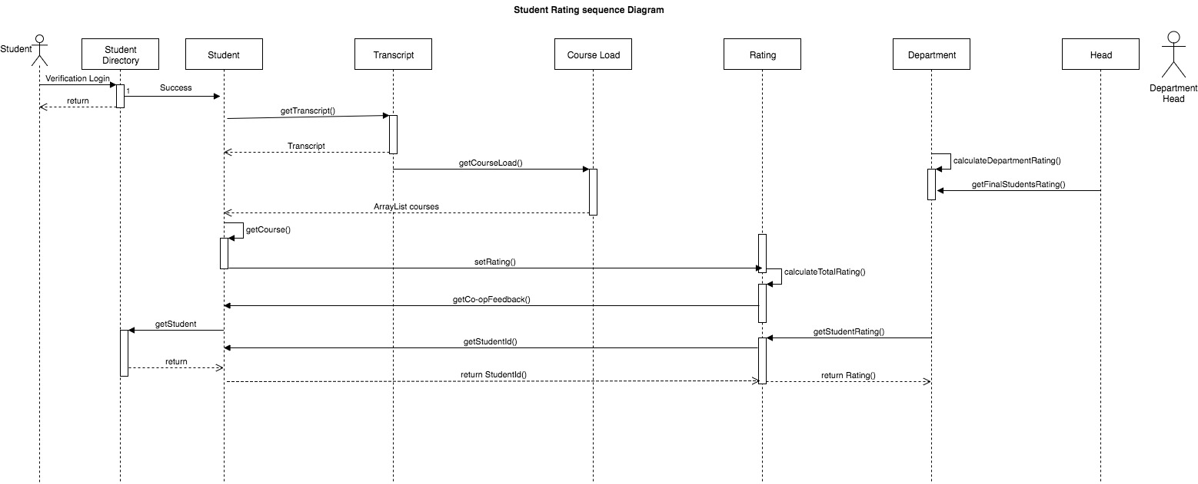

1. Alumni feedback sequence diagram

